Track Data

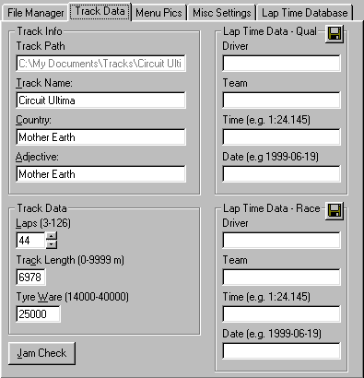
(Track Data)

Here you can change the different values of the track that will be exported to Gp2.

Track Info

Track Path, this is the path to the track, you can’t change this.
Track Name, the name of the track, this will be displayed in many menus in Gp2.
Country, the name of the country that the track is located in.
Adjective, the adjective of the country, e.g. Brazil is Brazilian. This will be set by Track Handler for most tracks but you my have to add this manually for some tracks.

Track Data

Laps, set the nr of laps in a 100% race not less then 3 and not more the 126.
Track Length, set the length of the track, this will help Gp2 to calculate the right average speed after a race.
Tyre Ware, set the tyre ware, high value=high ware and low value=low ware.

Lap Time Data–Race/Qual

Driver, set the driver name that has the best lap at this track.
Team, set the team that the driver was driving for when he set the fastest lap.
Time, the lap time.
Date, the date when the new record was set.

